Your Band  
NEWSLETTER

March , 2018

# Campus Selections

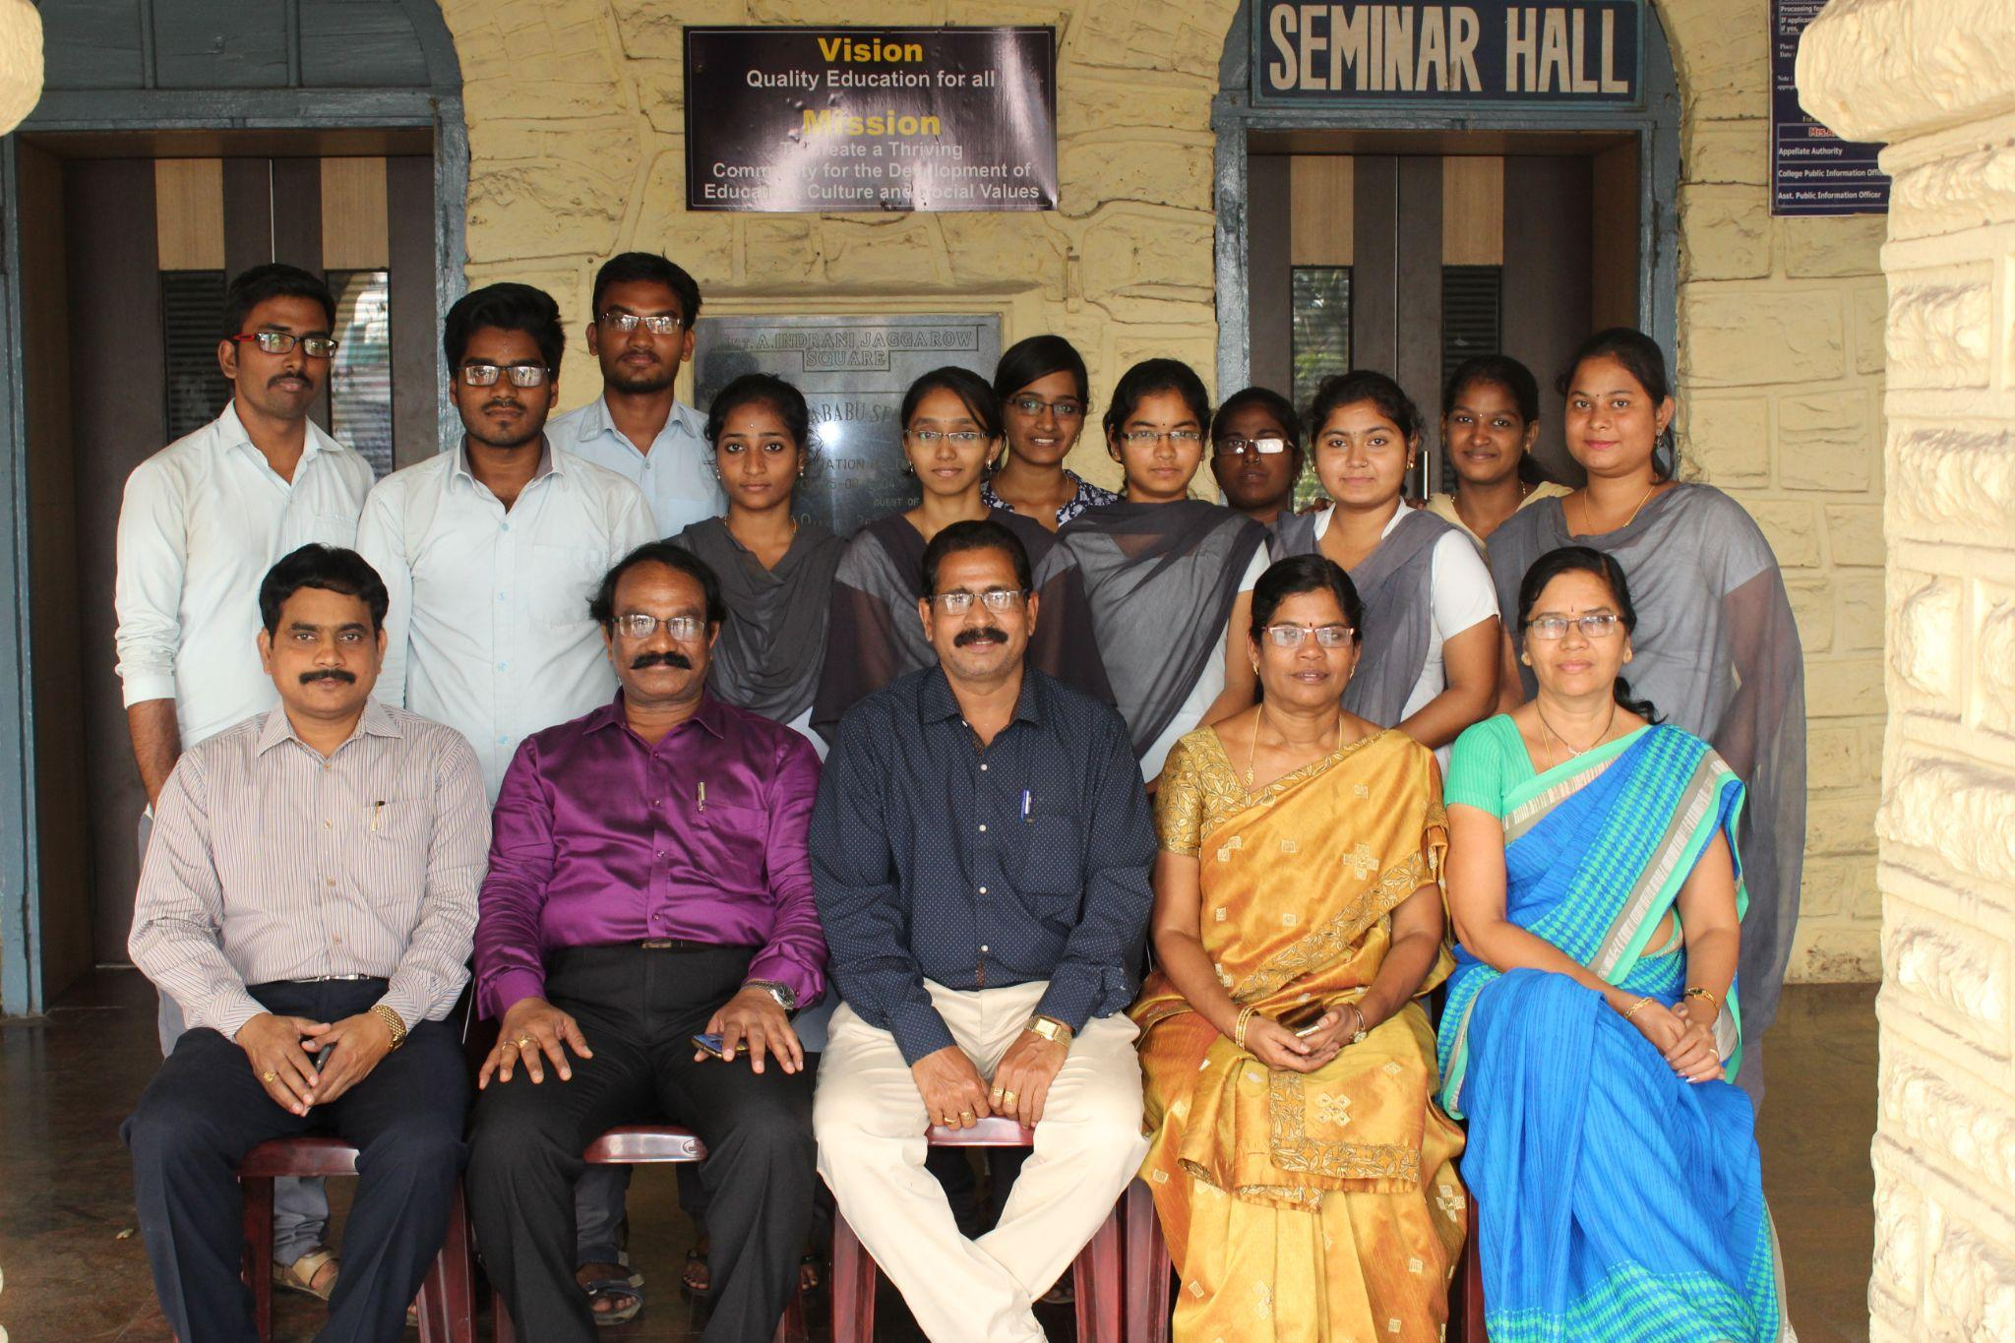

Scholarships

